

Website listing

This document has all the information needed to complete your listing on the FORMA website for the first event. If you manage multiple colleges please complete one form per institution. NB we will add more data points plus self-editing of profiles after the first event.

Part 1 - Photos

NB we can crop photos – sizes given are minimums.
- 1x logo photo – square min size 400x400px (needs to crop into landscape 400x200 – 100px off top and bottom). NB I have selected a buildings shot for each exhibitor as the default logo image. This works well as a set.
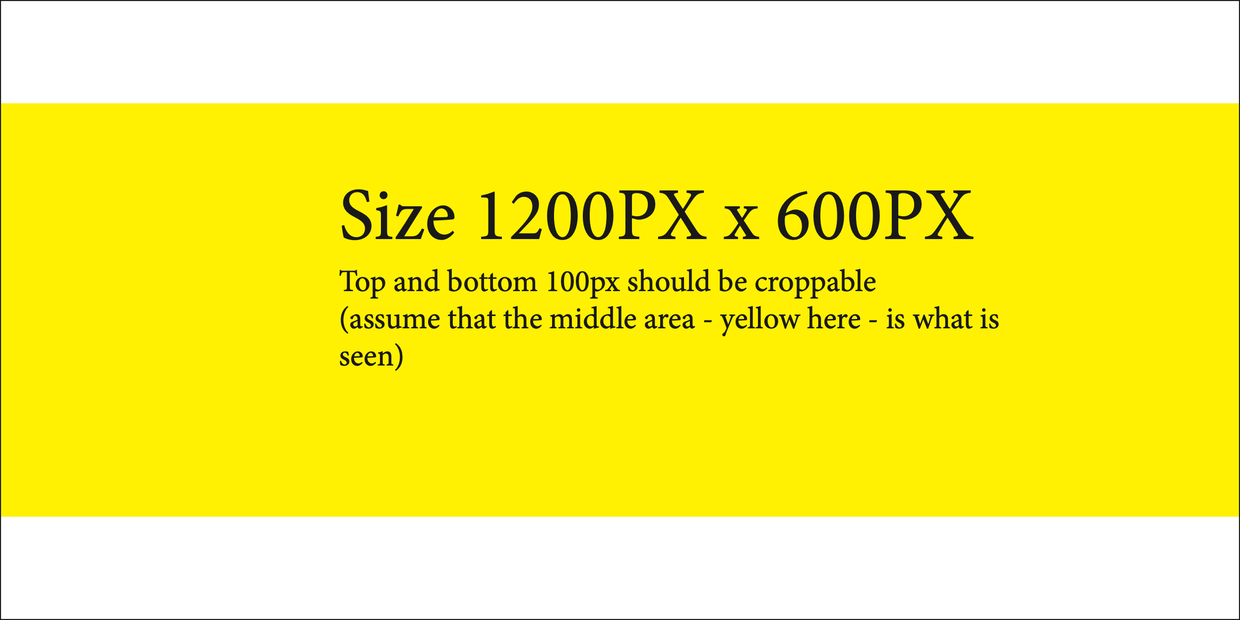
- 1x hero photo – each listing needs at least a hero image 1200x600px.
It should work cropped to 1200x400px
- Optional images
  - 8-12 subsidiary photos (landscape - minimum size 1280x1024px)

Please wetransfer photos in a single batch to guy@bonasmacfarlane.co.uk

Part 2 – Key Facts

NEW listings – please supply as much information as possible. For items with multiple choices please delete the not-relevant answers.

UPDATING listings - only update on this form the facts that need to be changed

Institution Name:

Slogan / Motto:

Address:
City:
County:
Postcode:
Country:

Telephone:
Email:
Website:

College Setting (please choose one and delete the others)
Rural
Town
Urban

Year established:

Courses (please delete the levels you do not do)
Foundation
Undergraduate
Postgraduate
Short Courses

Student population
Number of Students:
Number of Home Students:
Number of International Students:

Fees
Home BA fees pa
International BA fees pa
University Halls weekly fee range

Famous Alumni (max 8):

Short description (max 250 characters. This is shown in searches. See below for full description):

Part 3 – Videos

We can include multiple YouTube video in the listing. Please do NOT send the video, just the YouTube or Vimeo web address (URL) of each video.

YouTube/Vimeo URL:

Part 4 – PDFs

We can attach PDF documents / brochures to your listing

Please wetransfer in a single batch to guy@bonasmacfarlane.co.uk

Part 4 – Main Prose listing

This is the full description shown on the listing - 500-850 words:

