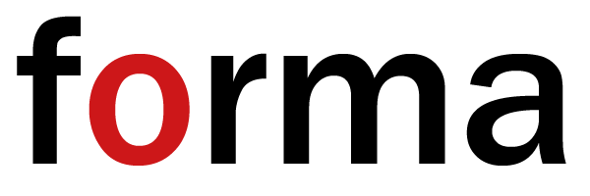

PRESS RELEASE
Introducing FORMA
Date: Friday 15th October 2021, 13:00 - 19:00
Location: One Marylebone, 1 Marylebone Road, London NW1 4AQ.
www.forma.show

“Art is one of the most important functions of the human… it is a privilege for anyone who chooses a career which relates to art. That will benefit your life and benefit society.”
Ai WeiWei - from his message to FORMA students
FORMA is a brand new platform that helps art & design students plan their education and careers.
The inaugural FORMA takes place on Friday 15 October, when a selection of the world’s leading art schools from the UK, France and the USA are gathering in London to meet sixth formers, foundation students and undergraduates.
FORMA has a uniquely international perspective, bringing art and design educators together from across the world. The aim is to encourage the next generation of artists and designers to think globally about where to study and where to base themselves after they finish studying.
How will FORMA do this?
- Admissions teams from some of the world’s leading art schools will be on hand to review student portfolios, discuss course choices, and provide practical information about studying at and applying to their colleges.
- The exhibiting art schools are all highly competitive, with many more applicants than places. At FORMA a programme of interactive workshops and masterclasses will show students how to improve their portfolios, giving them the best chance of success at interview. They will also discover the application support available from outreach programmes, summer schools and creative mentoring programmes.
- At the London show FORMA is launching an ongoing programme of year-round online talks and workshops that will feature inspirational artists, designers, curators and educators from across the world, talking about how to choose and apply to art schools, make the most of your art school education and manage the first steps from course to career.
Attending the show will be a new generation of artists, fashion designers, creative directors, photographers, film makers, architects, graphic designers.
Ticket holders for the first London FORMA include:
- Sixth formers & art teachers from schools and colleges across the UK
- Foundation students in London considering undergraduate choices
- Undergraduates at London art schools considering career and post-graduate options
- Parents
About the organisers
Next Step Exhibitions Ltd organises the Independent Schools Show, which is held in London and 13 cities across the globe. Established in 2005, the show is the largest school open day in the world, bringing together over 240 leading independent and international schools from the UK, US and Europe,
Part of the Next Step Education group, the school shows are complemented by our sister organisations - Bonas MacFarlane, which provides educational support and advice to parents and students worldwide, and Next Step Foundation, our charitable arm, which provides university application support, mentoring and advice to UK students from widening participation backgrounds.
For further information please contact
Joanne MacAlesher
Media & Marketing FORMA
e. joanne@forma.show
m. 07801 854020

